**List of all assumptions made:**

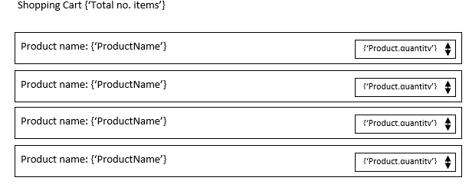Cart component illustration